This is the seasonal update to Melbourne’s Annual Water Outlook 2026 which was released in December 2025.
Over the past 3 months, from 1 March 2026 to 1 June 2026, Melbourne’s storages declined by 6.1% (111 billion litres). As of 1 June 2026, storages are at 63.4% and the volume available for Greater Melbourne (Greater Western Water, South East Water and Yarra Valley Water) is around 572 billion litres. Autumn rainfall was below average, and Melbourne’s storages have experienced a steep decline over the past 12 months and are now 9.5% (172.1 billion litres) lower than the same time last year.

To support water security, 150 billion litres of water was ordered from the Victorian Desalination Plant for the 2026/27 supply year, and this is currently being delivered into the system. Orders from the Victorian Desalination Plant are a critical part of our response to current dry conditions.

Over the past 24 months, Melbourne experienced some of the lowest rainfall and inflows on record – similar to the worst years of the Millennium Drought. As a result, water in storage has tracked around the dry and extreme dry year scenarios from the 2025 Annual Water Outlook. This has continued for the 2026 Annual Water Outlook (refer Figure 1). Melbourne’s storages are 24% (around 432 billion litres) lower than at the same time two years ago, due to a combination of very low rainfall, record-low inflows, and higher water use.

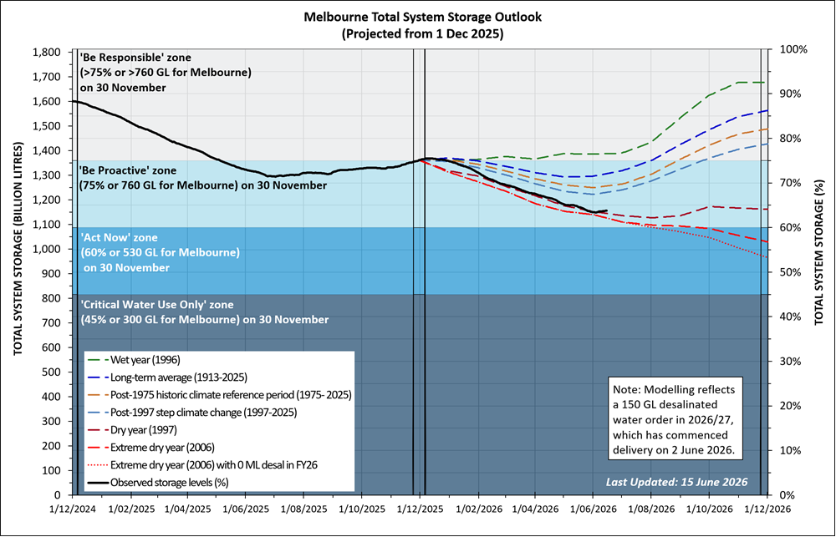
Figure 1: Comparison with 2026 Annual Water Outlook period.

Residential water use was around 162 litres per person per day over the past 12 months, which is about 2.4% lower than the previous March update (166 litres per person per day).

Likelihood of restrictions
If we experience continued dry conditions through 2026, restrictions are possible over summer 2026/27. Permanent Water Saving Rules continue to apply. Local restrictions could be needed at different times for some regions, due to local storages or operational constraints.

Local storage outlook for Greater Western Water
Drinking water in the northwest of the Greater Western Water service region comes from local creeks, reservoirs and bores (groundwater), supplemented by water from the Melbourne system.
Local storages have declined by 7.3% since 1 March 2026 and are tracking along the dry and extreme dry year scenarios. As of 1 June 2026, local storages are at 54%.

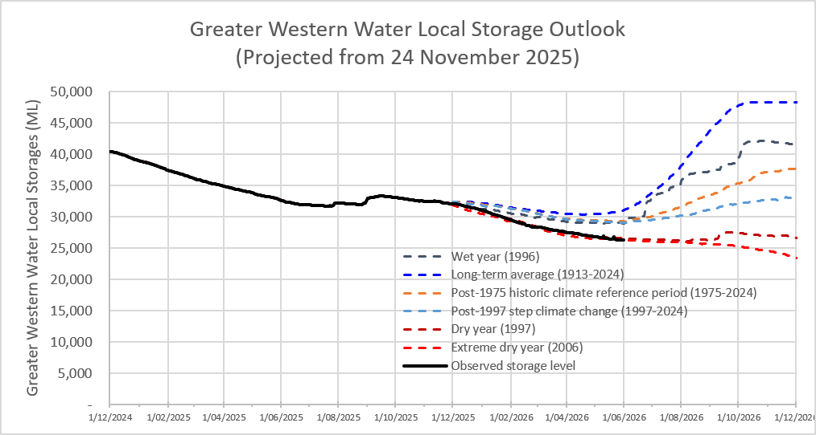
Figure 2: Comparison with 2026 Annual Water Outlook period Greater Western Water local storages.

