This is the September quarterly update to Melbourne’s Annual Water Outlook 2026, which was released in December 2025.
From 1 June 2026 to 1 September 2026, Melbourne’s storages increased by 5.9% (106.6 billion litres). Despite this winter recovery, storages remain 3.1% (56.7 billion litres) lower than at the same time last year and more than 20% lower than the same time 2 years ago. As of 1 September 2026, storages are at 69.3% with around 642 billion litres available for Greater Melbourne (Greater Western Water, South East Water and Yarra Valley Water) and the connected regions. Winter rainfall was 22% below average, while inflows to Melbourne's major storages were 4% above average.
To support water security, 150 billion litres of water was ordered from the Victorian Desalination Plant for the 2026/27 supply year and is being delivered into the system. Orders from the Victorian Desalination Plant are a critical part of our response to current dry conditions.

From December 2025 to May 2026, Melbourne's water storages tracked around the dry year scenario from the 2026 Annual Water Outlook (Figure 1). Storages have increased by 5.9% over winter, 2.2% was from desalinated water deliveries. Even with this winter recovery storages have not regained the volumes lost during the extremely dry conditions experienced over the past 2 years. With El Niño conditions now declared and the Bureau of Meteorology forecasting below-average spring rainfall across Victoria, there is an increased likelihood of below-average inflows over spring.
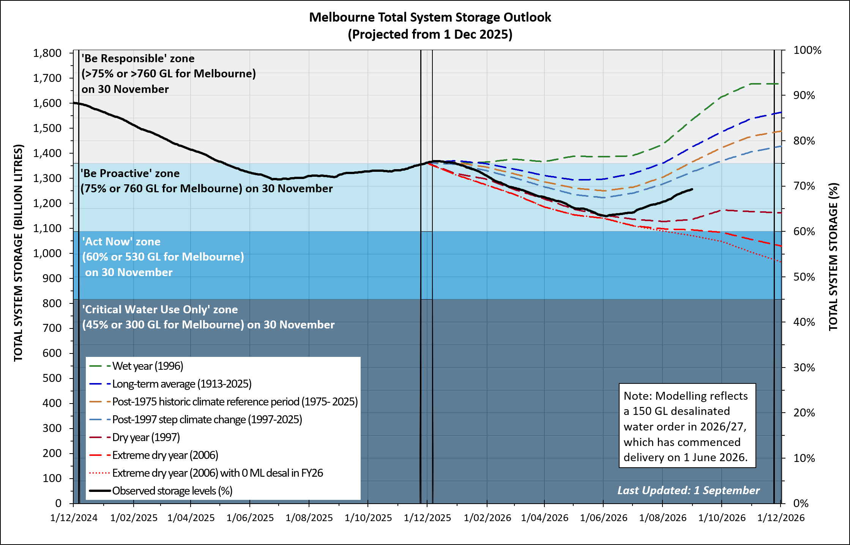
Figure 1: Comparison with 2026 Annual Water Outlook period.

Residential water use was around 159 litres per person per day over the past 12 months, which is about 1.8% lower than reported in the previous June update (162 litres per person per day).

Likelihood of restrictions
If we experience continued dry conditions through spring, water restrictions are possible over summer 2026/27.

Permanent Water Saving Rules continue to apply. Local restrictions could be needed at different times for some regions, due to local storages or operational constraints.

Local storage outlook for Greater Western Water
Drinking water in the northwest of the Greater Western Water service region comes from local creeks, reservoirs and bores (groundwater), supplemented by water from the Melbourne system.
Local storages have increased by 18% since 1 June 2026 and are tracking above the post-1997 average scenario. As of 1 September 2026, local storages are at 72%. While local storage levels increased over winter, a hot and dry spring can cause them to drop quickly.

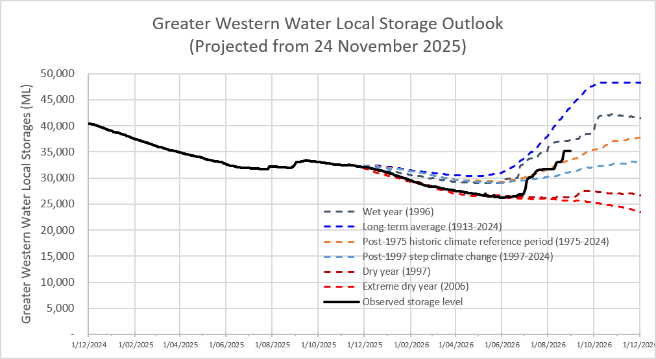
Figure 2: Comparison with 2026 Annual Water Outlook period Greater Western Water local storages.

